**Introduction to Consequentialism**

**Overview**:

Consequentialism is a branch of ethical philosophy that examines the consequences of an action to determine whether the action was good or bad. Through a house building exercise, we will examine how choices can affect outcomes, and why it’s important to think ahead before making choices.

**Goal**:

To get students to think about the consequences of actions. To make them realize they could alter situations to have a different outcome. While also getting them to think about how planning ahead before acting can be beneficial to getting a desired outcome.

**Materials**:

6 pieces of printer paper

A pen/pencil (optional: color pencils/crayons)

**Activity**:

1. The first part of this activity is a building exercise. Each student should have prepared 3 sheets of printer paper and a pen/pencil. Before getting into the lesson, tell the students that they have 5 min to build a house using paper and a writing utensil (or crayons). In the time allotted for the kids to build the house the instructor should also build one for reference in the lesson. At the end of the time, ask the students to present their houses. Make sure to have them explain how they built their house. Here’s sample images of a paper house for reference of what the project could look like (here only 2 pages were used). Do not show the students the sample pictures :

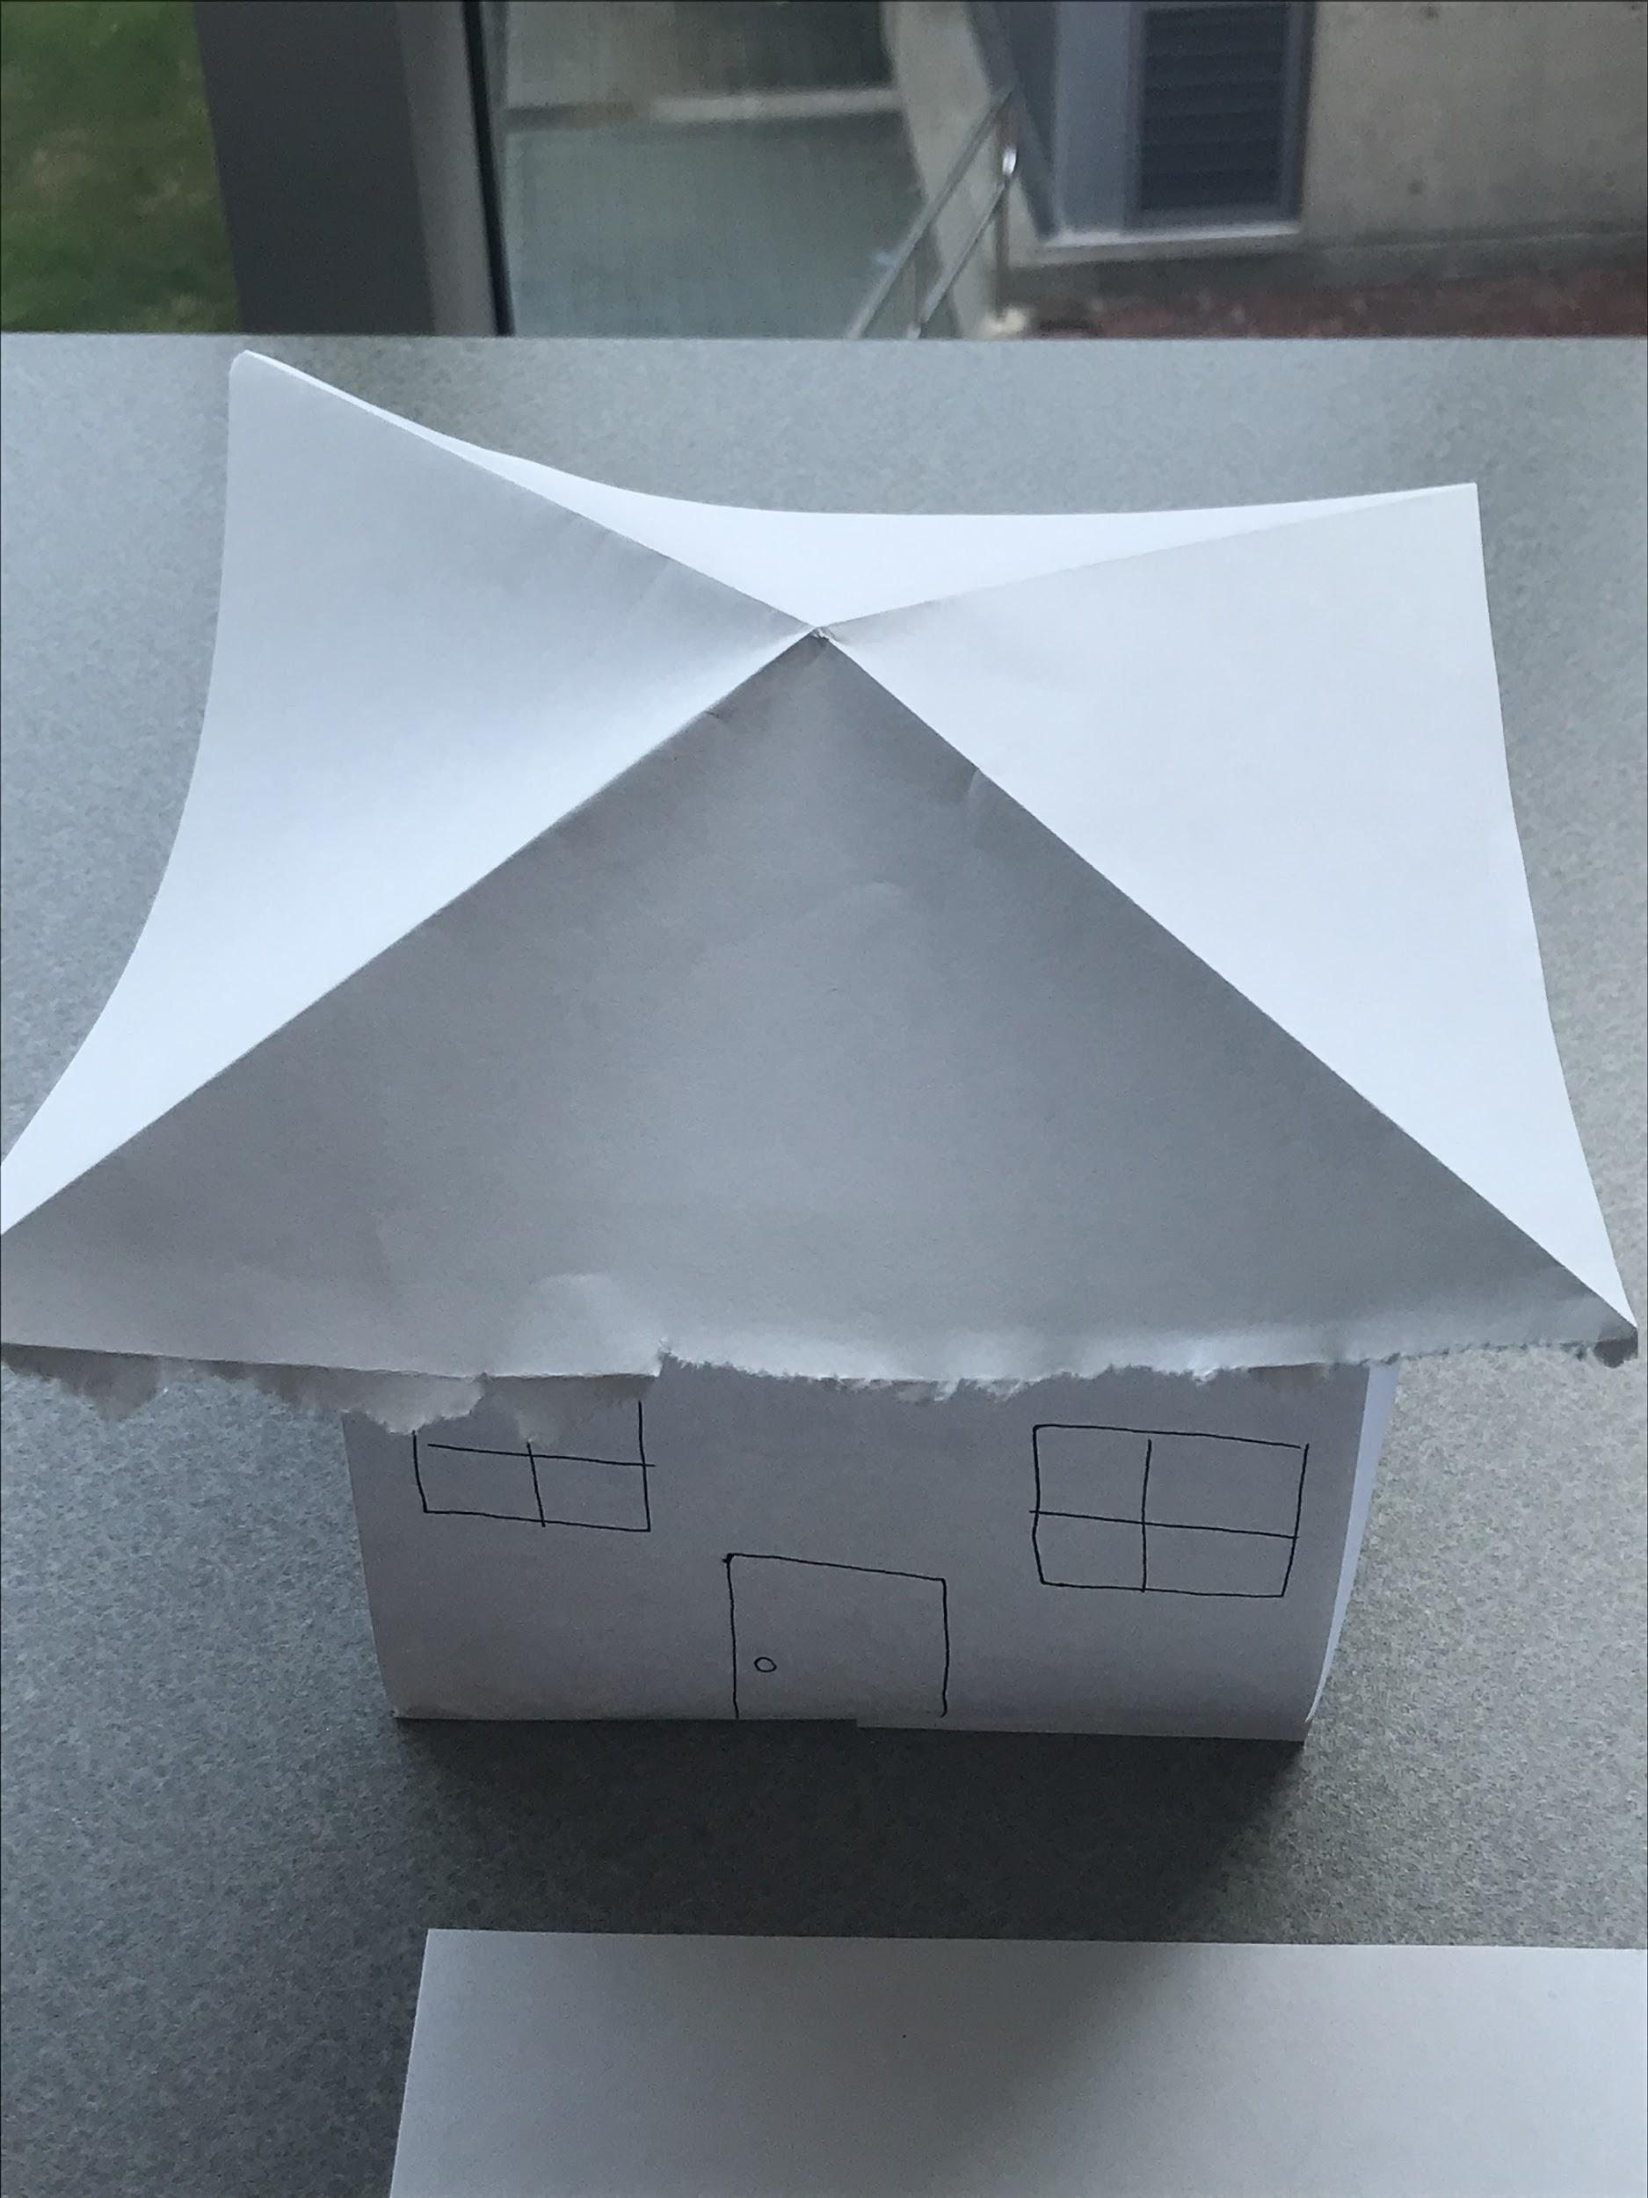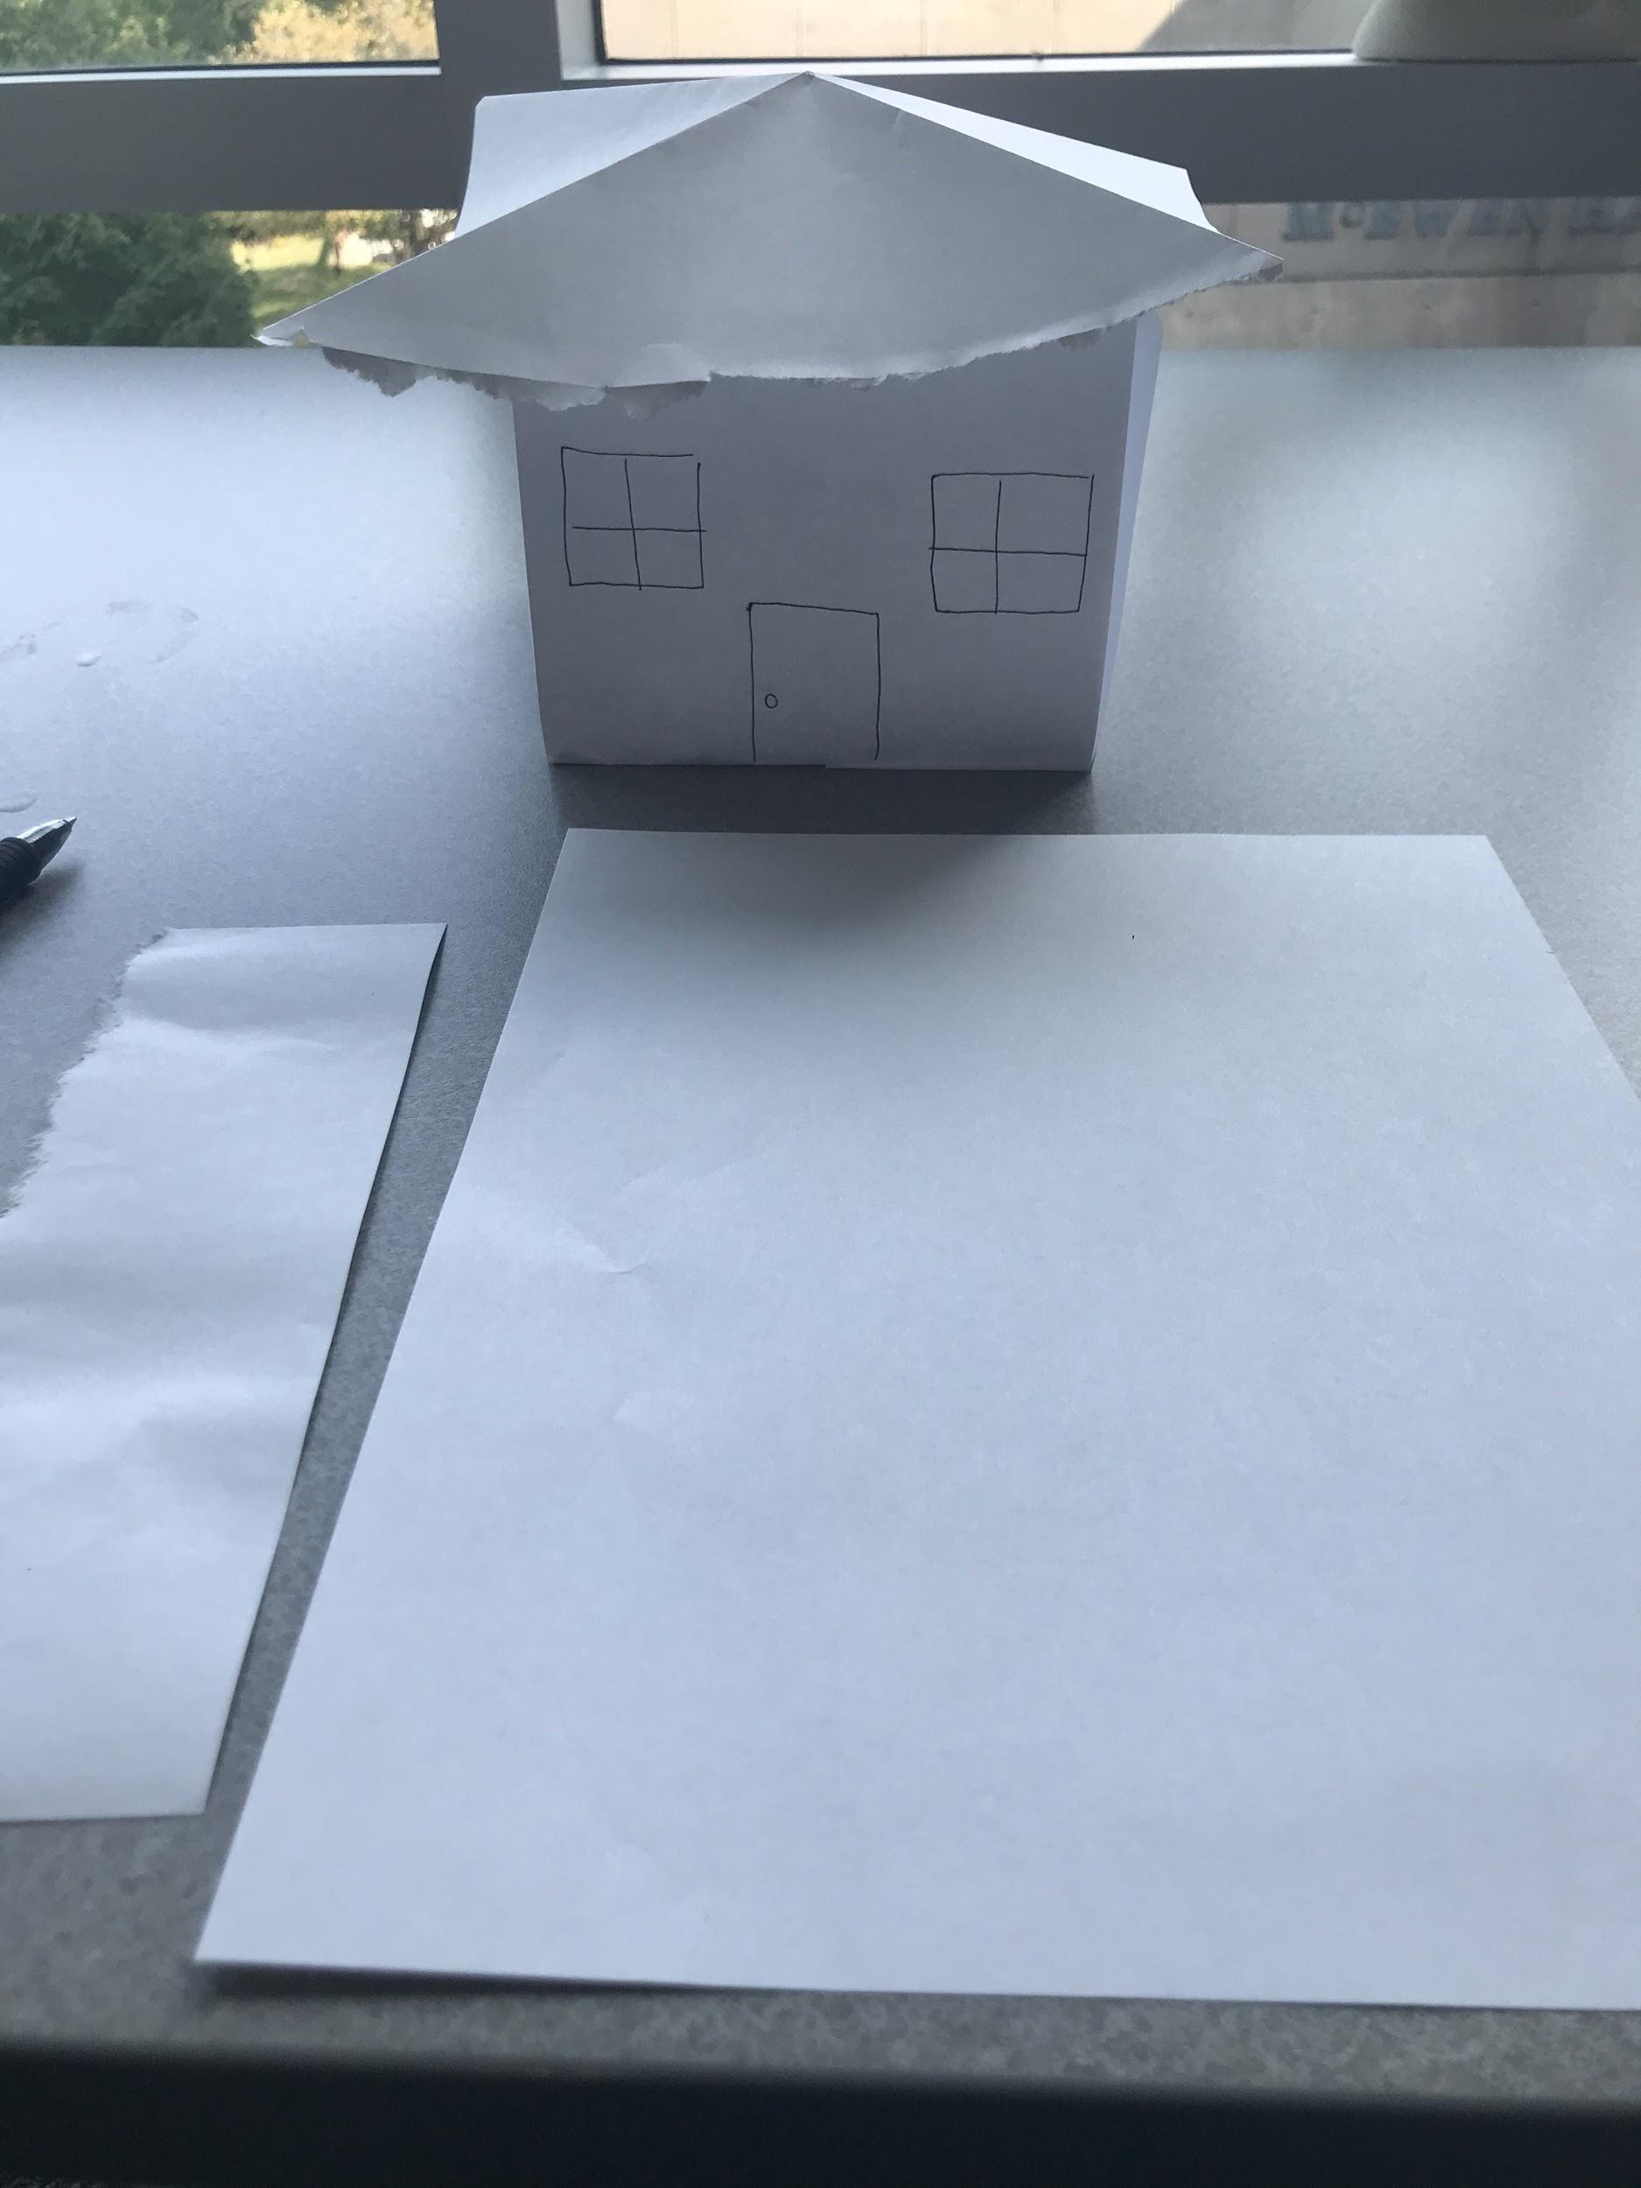

1. Now, ask the students if they used all three sheets of paper. If so why? Ask each of them what they could have done differently to use 2 pieces over 3. If any students drew a door/windows on their house, ask what prompted them to do so. If they used color pencils as them about any designs they decided to add to the house. The goal here is to start focusing on the choices they made in the activity
2. After getting them to think about the choices they made in building their house. Introduce the idea of consequences. Ask them if anyone knows what a consequence is. If no one knows, tell them the definition of consequence is the result of an action. Elaborate that consequences can be good or bad depending on the situation. Correlating consequences to the activity an example would be: the consequence of using all three papers for my house is I don’t have any more to build a chimney (*a bad consequence*). Or another example could be using all three papers I was able to make a stable house with a roof (*a good consequence*) You can further this by asking students if they would or wouldn’t live in the house they made. If they say no because there are no windows or doors, talk about the consequences of how they made the house and their decision on whether or not to live there. Make them think about the outcome of their choices and ask them what they would have done differently when making it. Give them about 5 min to write down different ways they can build a better house using the materials they had initially.
3. After the 5 min are up, let them retry to build a house with the remaining 3 pieces of paper in 5 min. Then ask them again how they made it. What changes did they make and would they live in the second house versus the first one?

**Reflection**:

How is this house better than the last one? How did planning how to build the house ahead of time affect the outcome? Was it easier to build the house the first or the second time? Why? Does thinking before an action more likely to lead to good or bad consequences? Why or why not?