**Lesson #2- Wonder in the Outdoors**

**The Question: What do you wonder about when you are outside?**

The goal of today’s lesson is to get outside! What do the outdoors make you think about? What do you notice when you are outside? What do you see, hear, smell or feel? Do these things make you wonder about anything?

**Overview:**

1. **Go outside**
2. **Go for a walk**
3. **Take some pictures of things you notice**
4. **What do you wonder about the picture**
5. **Wrap-Up**

**Activity:**

Today we are going outside!

There are so many different things to see outside in nature!

* How do you feel when you are outside? Is it different from how you feel when you are inside?

What do you think about when you are in nature?

Take 5 pictures of things you notice outside.

Then write down or tell someone something they make you wonder about.

What noises do you hear? What do you smell?

Do the things you hear or smell make you wonder about anything?

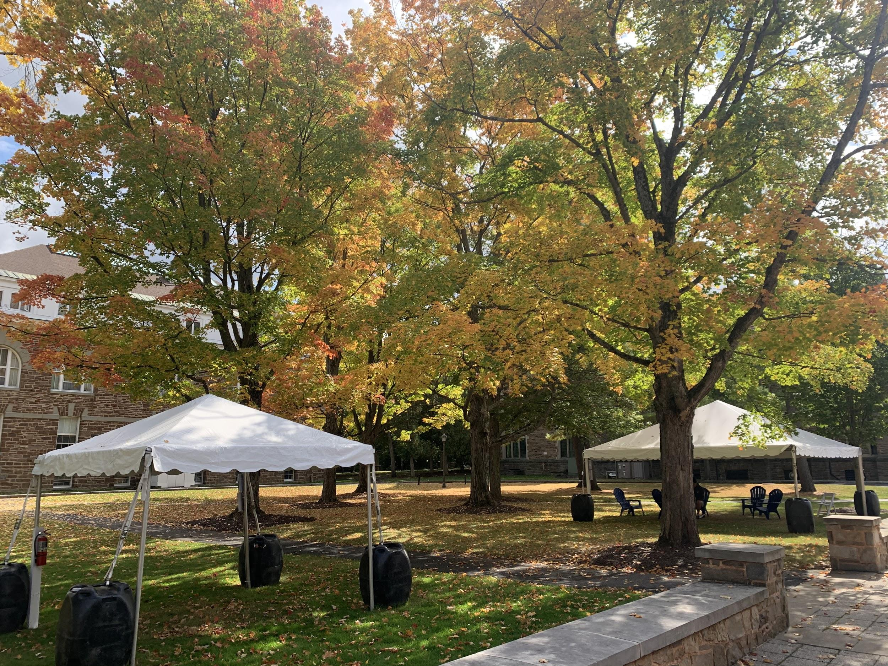

For example, in this picture I wonder:

* How old are the trees?
* How long will it take for all the leaves to fall off?
* If I raked all the leaves into a pile, how big would the pile be?
* What do these trees look like at different times of year?

**Wrap-Up:**

What is one thing you’re thinking about after your nature walk?

How did this activity make you feel?

* Would you feel different if you had done this activity inside instead of outside?

Bring something (an acorn, or leaf , etc) back inside with you to remind you to keep wondering about your surroundings!