**Word Challenge**

*K-12 Philosophy Lesson Plan*

**Age group:** Grades 3-5

**Topic:** Language and thought

**Introduction -**

The goal of this lesson is to encourage students to reflect on how they use words differently than others. Although we speak the same language to others in a conversation, we don’t all use and know the same words. This lesson challenges students to explore their vocabulary, refreshing their understanding of the words they use, and allowing them to reconsider their word choice.

**Challenge #1 - Word search**

Set a timer for 5 minutes

Ask students to write down all of the words they find in the word search puzzle found at the bottom of this lesson plan. (***NOTE***- have students find words without the list to guide their search)

***alternative option*** - create your own word search puzzle with <https://thewordsearch.com/maker/>, be sure to include pairings of words that are commonly associated with each other as well as a mix of easier and tougher words. Since this lesson uses the word search game in a non-traditional way, download your word search as an image and crop the parts that you wish to display.

**Questions to ask once time is up:**

* *Which words did you find?*
* *Why do you think you found these words?*
* *Did you have a strategy?*
* *Do you use these words often?*

Once students have shared out, show them the list of words included in the puzzle (found below the word search puzzle on the bottom page)

**Questions to ask:**

* *Which words did you not find?*
* *Why do you think you missed these words?*
* *Do you use these words often?*

**Challenge #2 - Word Connection**

Set a timer for 2 minutes

Show the word “powerful” to students and have them write down any words that come to mind when they think of this word

**Questions to ask once time is up:**

* *What words did you write down?* 
  + **optional** - have students use the thumbs up feature to indicate when they had the same word as one of their peers
* *Why do they remind you of the word powerful?*

Once 3-4 students have shared,

* *Did we all have the same words?*
* *Why might some students have different words than others?*
* *Where do we get our words from?*

**Wrap-up:**

* *Is there one, right way to use our words?*
* *Do you use different words in class than you do at home? With friends?*
  + *Why?*

Encourage students to keep a “Word challenge” journal. Challenge them to ask 3 of their friends/family members what words come to mind when they think of the word “powerful” or another word of their choice. Have them log their answers in the journal along with their own answers. Once they have collected their answers, ask them to write down 3 observations about the answers they collected.

**---**

**Word search on next page**

**Word Search Puzzle:**

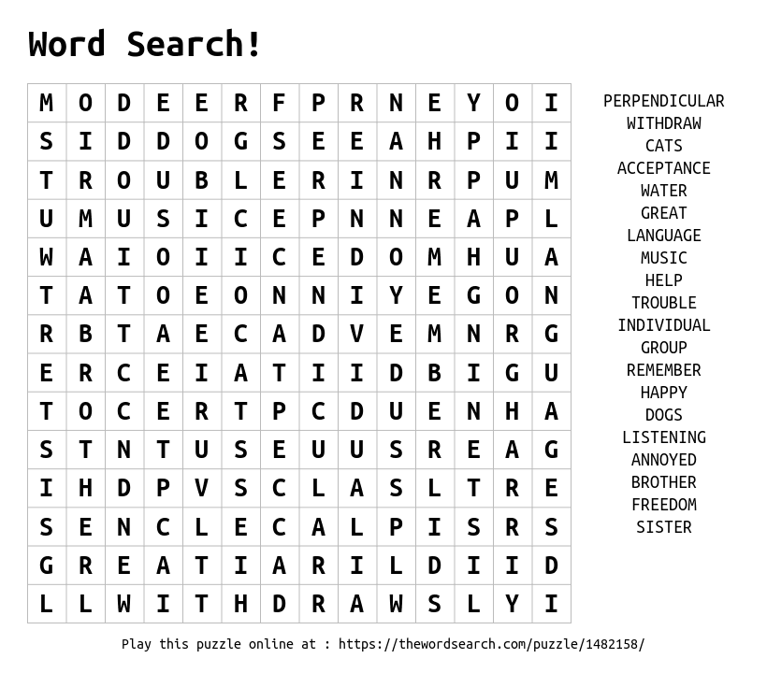

**Words included:**

